Credential Suspension

1. 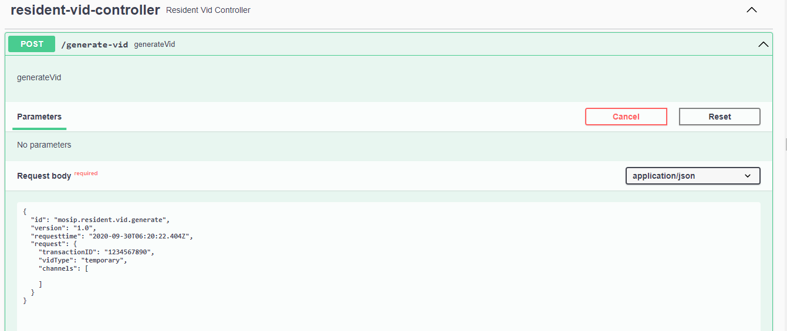Generate a credential.

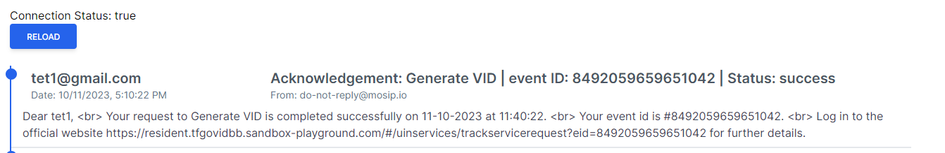Notification:

1. 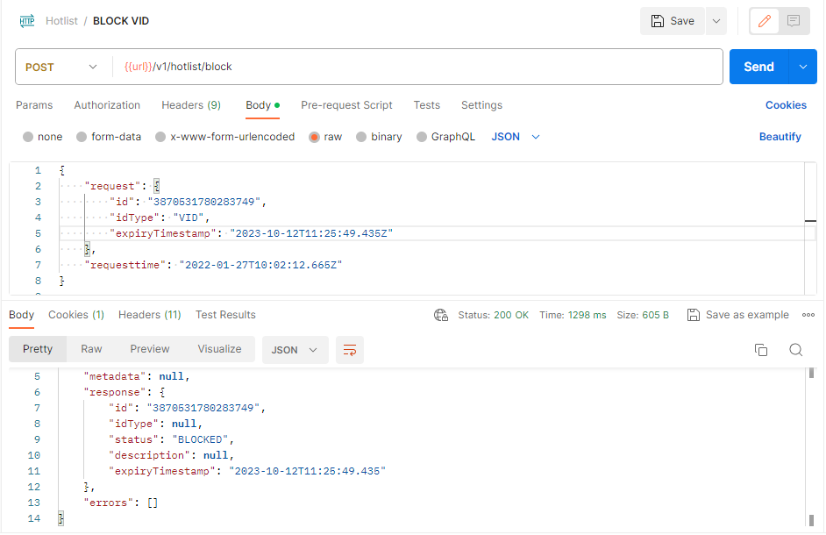 Suspending credential for pre-defined period, if its lost/stolen.

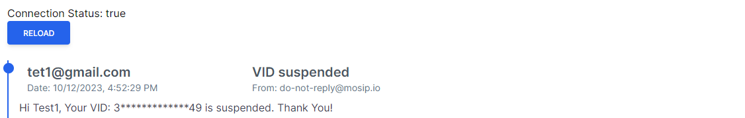Notification

1. 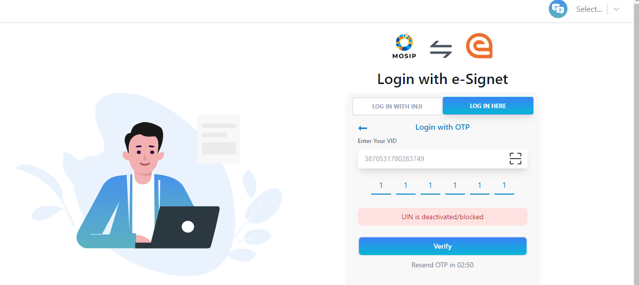Login to resident portal with suspended credential.
2. After pre-defined period credential suspension will be terminated and able to login to resident portal with terminated suspension credential.



